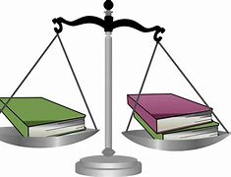
Oregon Criminal Law
Resource Guide
Jury

Oregon Uniform Jury Instructions: Criminal Vols. 1-2 / Oregon State Bar

CLE Bar Books
Criminal Law Vols. 1-3 / Oregon State Bar
Juvenile Delinquency Vols. 1-2 / Oregon State Bar

*Additional Titles Available

DWI Practice
DUII Notebook 2020 Ed. & 2022 Update / OCDLA

Statutes & Codes
Criminal Code of Oregon / State of Oregon Legislative Committee
Federal Criminal Codes and Rules / Thomson Reuters/Westlaw
Oregon Revised Statutes 2021 / State of Oregon Legislative Committee

Practice Essentials

Criminal Evidentiary Foundations / Edward Imwinkelried

Criminal Law Handbook / NOLO

Criminal Procedure – West’s Criminal Practice Series / Wayne LaFave

Felony Sentencing in Oregon / OCDLA

Racketeer Influenced Corrupt Organizations / David McCormack

Practice Materials

West’s Oregon Digests 2d / Thomson Reuters – Westlaw

Treatises
Administrative Law Treatise
Treatise on the Law of Contracts

