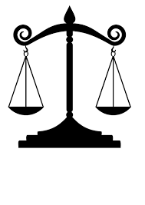Family Law Resource Guide

|  |  |
| --- | --- |
| **Practice Essentials**  **O’Connor’s Texas Family Law Handbook** / Joan Foote Jenkins & Randall B. Wilhite, O’Connor’s, 2022(reference desk).  **O’Connor’s Texas Family Law Forms** / Randall B. Wilhite, O’Connor’s, 2021(reference desk).  **Texas Family Law Practice Manual, 2020 Edition** / State Bar of Texas, 2020 (reference desk).  **Texas Family Law Practice and Procedure /** John D. Montgomery, *et. al.*, Matthew Bender, 2021 (Texas Section).  **Texas Practice Guide: Family Law** / Kathryn J. Murphy, *et al.*, West, 2021-2022 (Texas Section).  **Texas Practice Series: Handbook of Texas Family Law (Vol. 33)** / John F. Elder, West, 2021-2022 (Texas section). |  |